Lin re

*by* Ananthajothi K

**Submission date:** 25-Nov-2024 10:00PM (UTC-0600)

**Submission ID:** 2532521824

**File name:** FINAL_REPORT_133_155.pdf (735.65K)

**Word count:** 5328

**Character count:** 32594

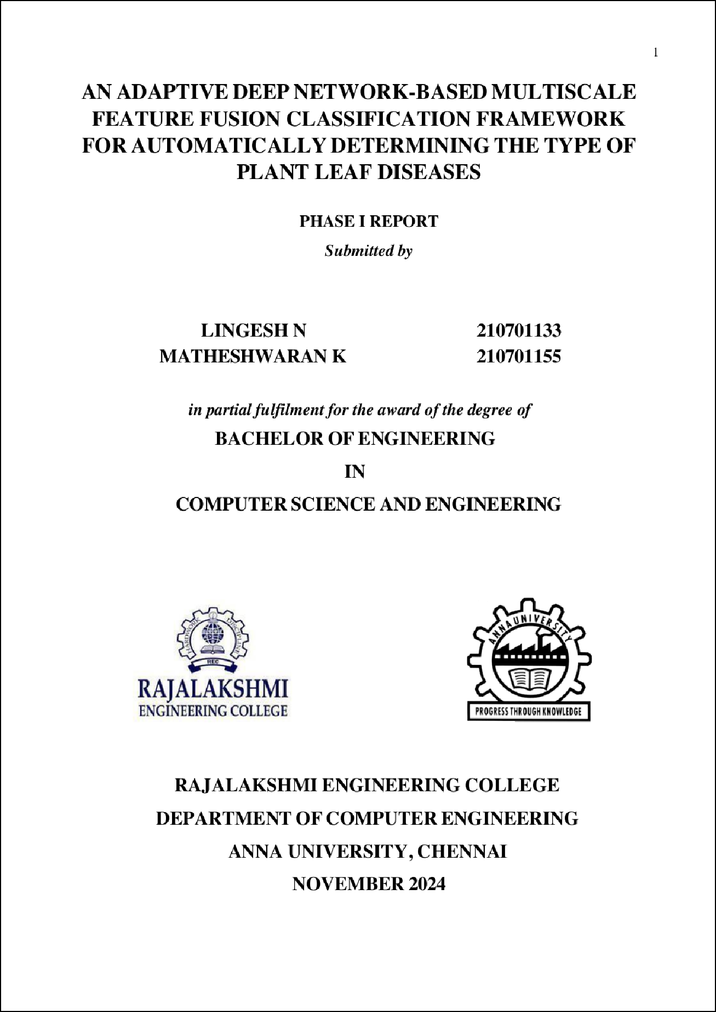

8

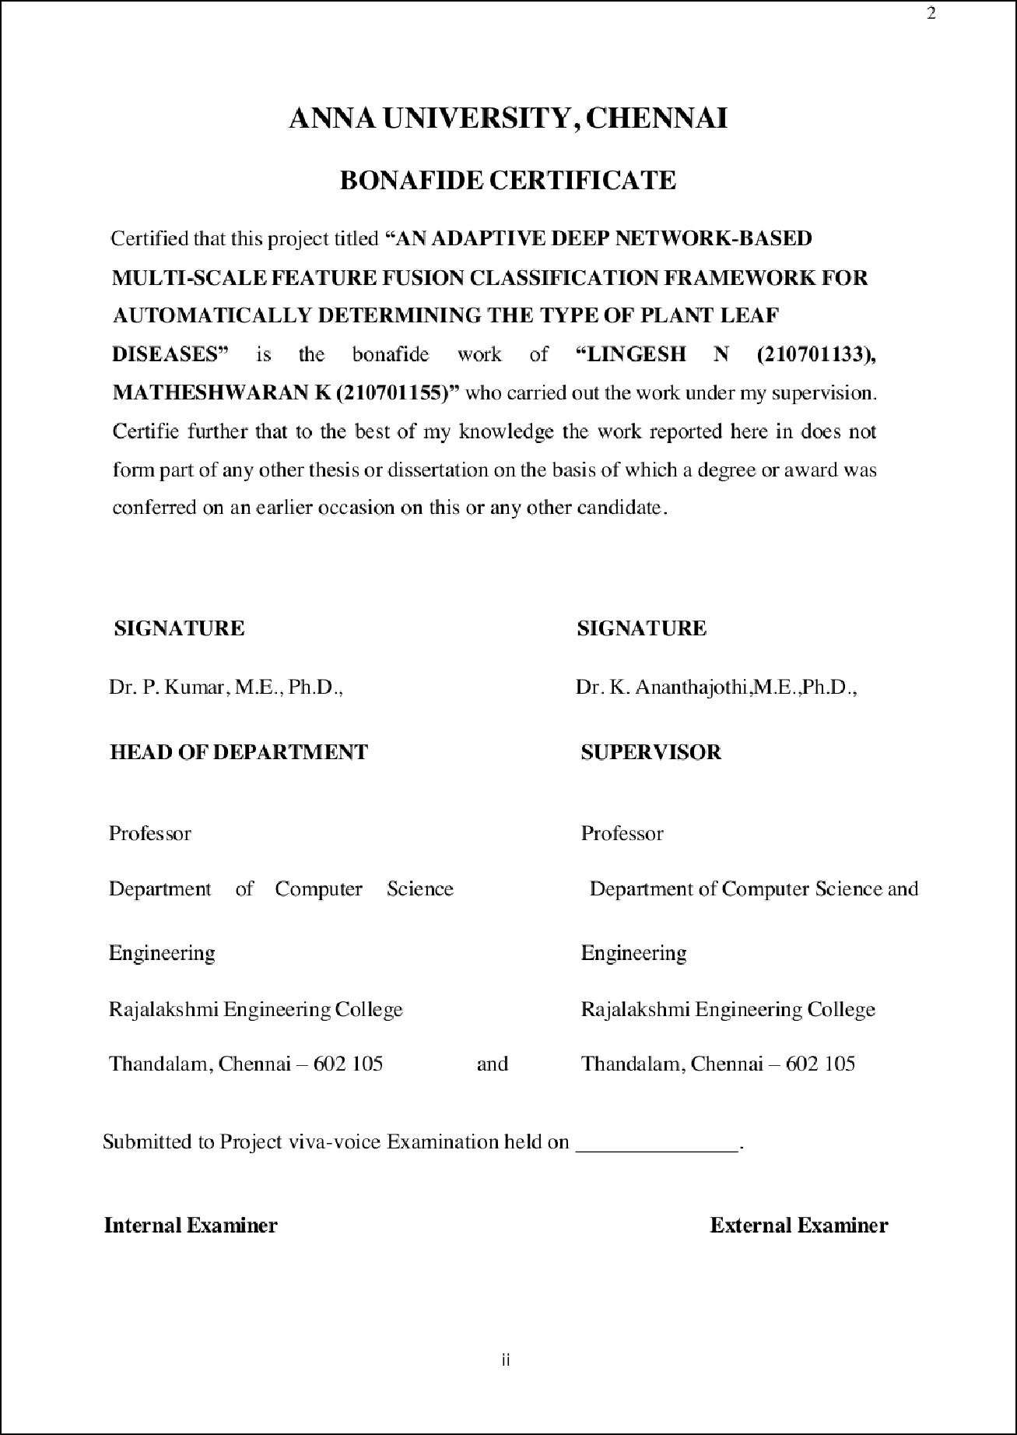

1

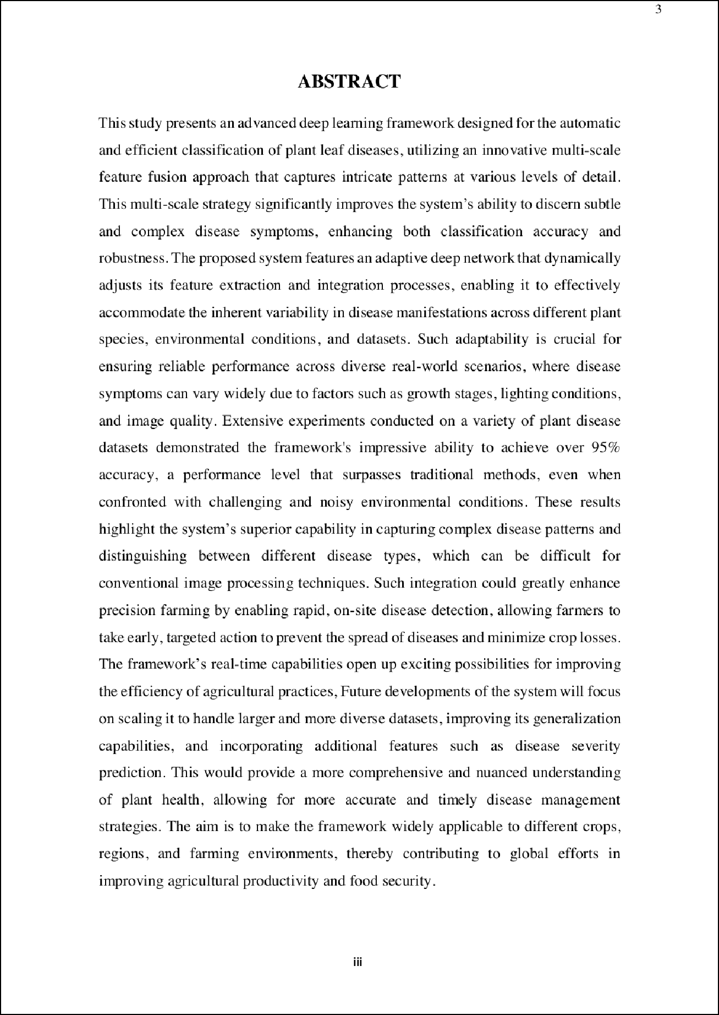

39

23

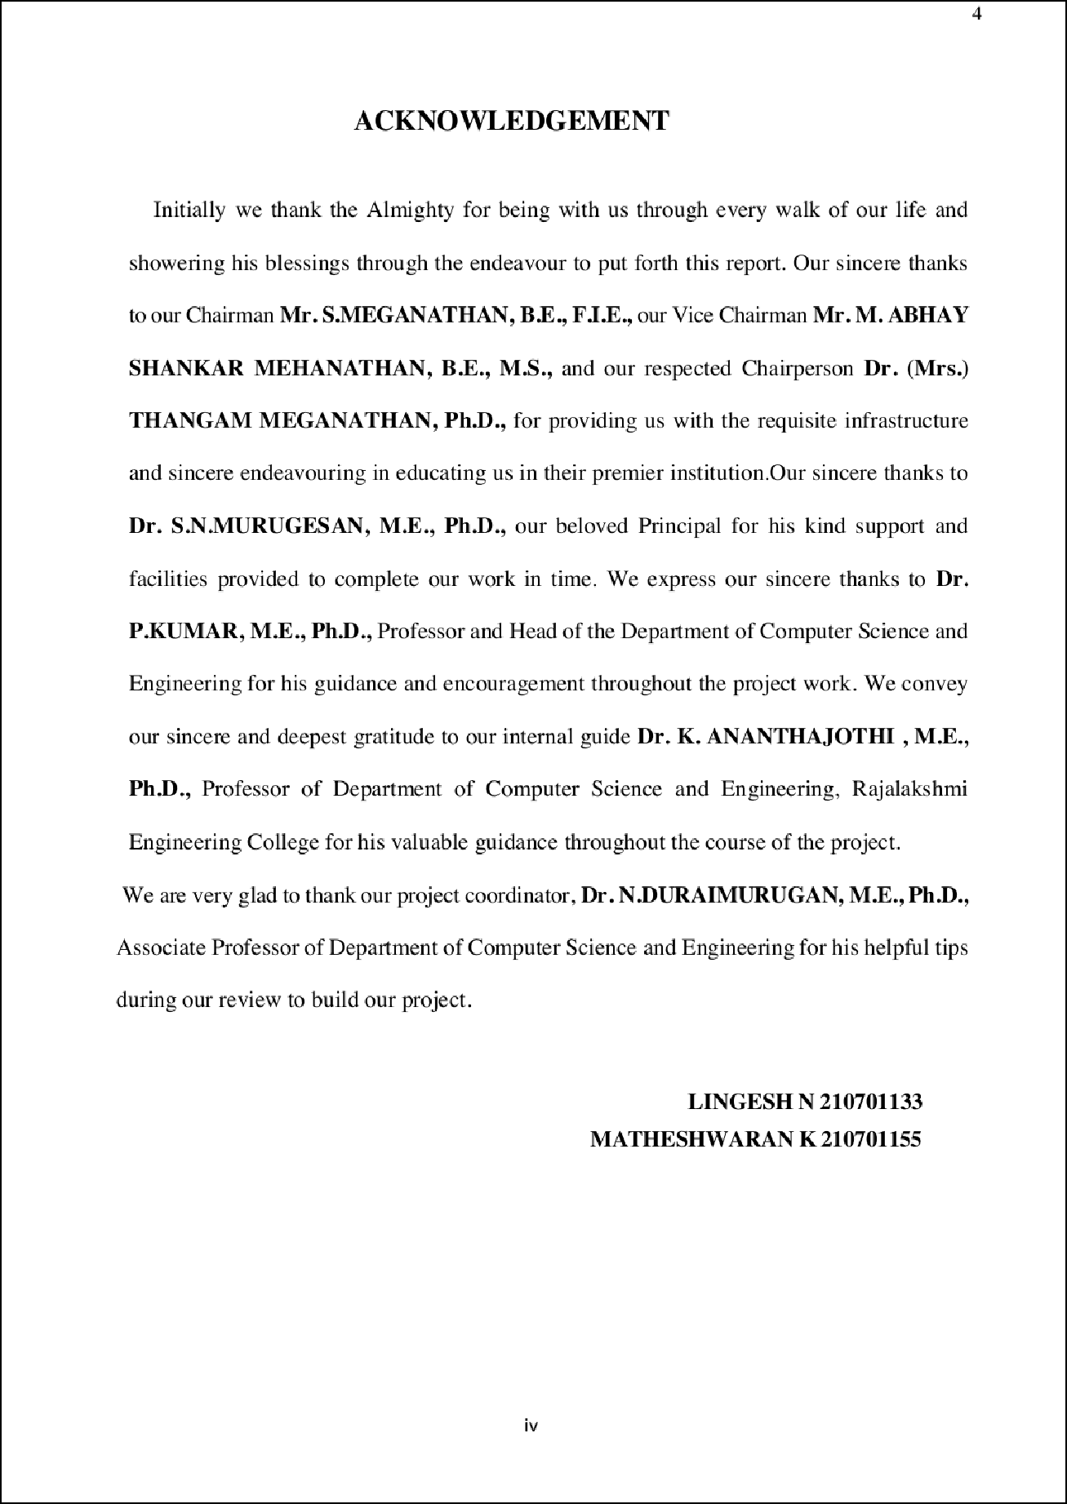

1

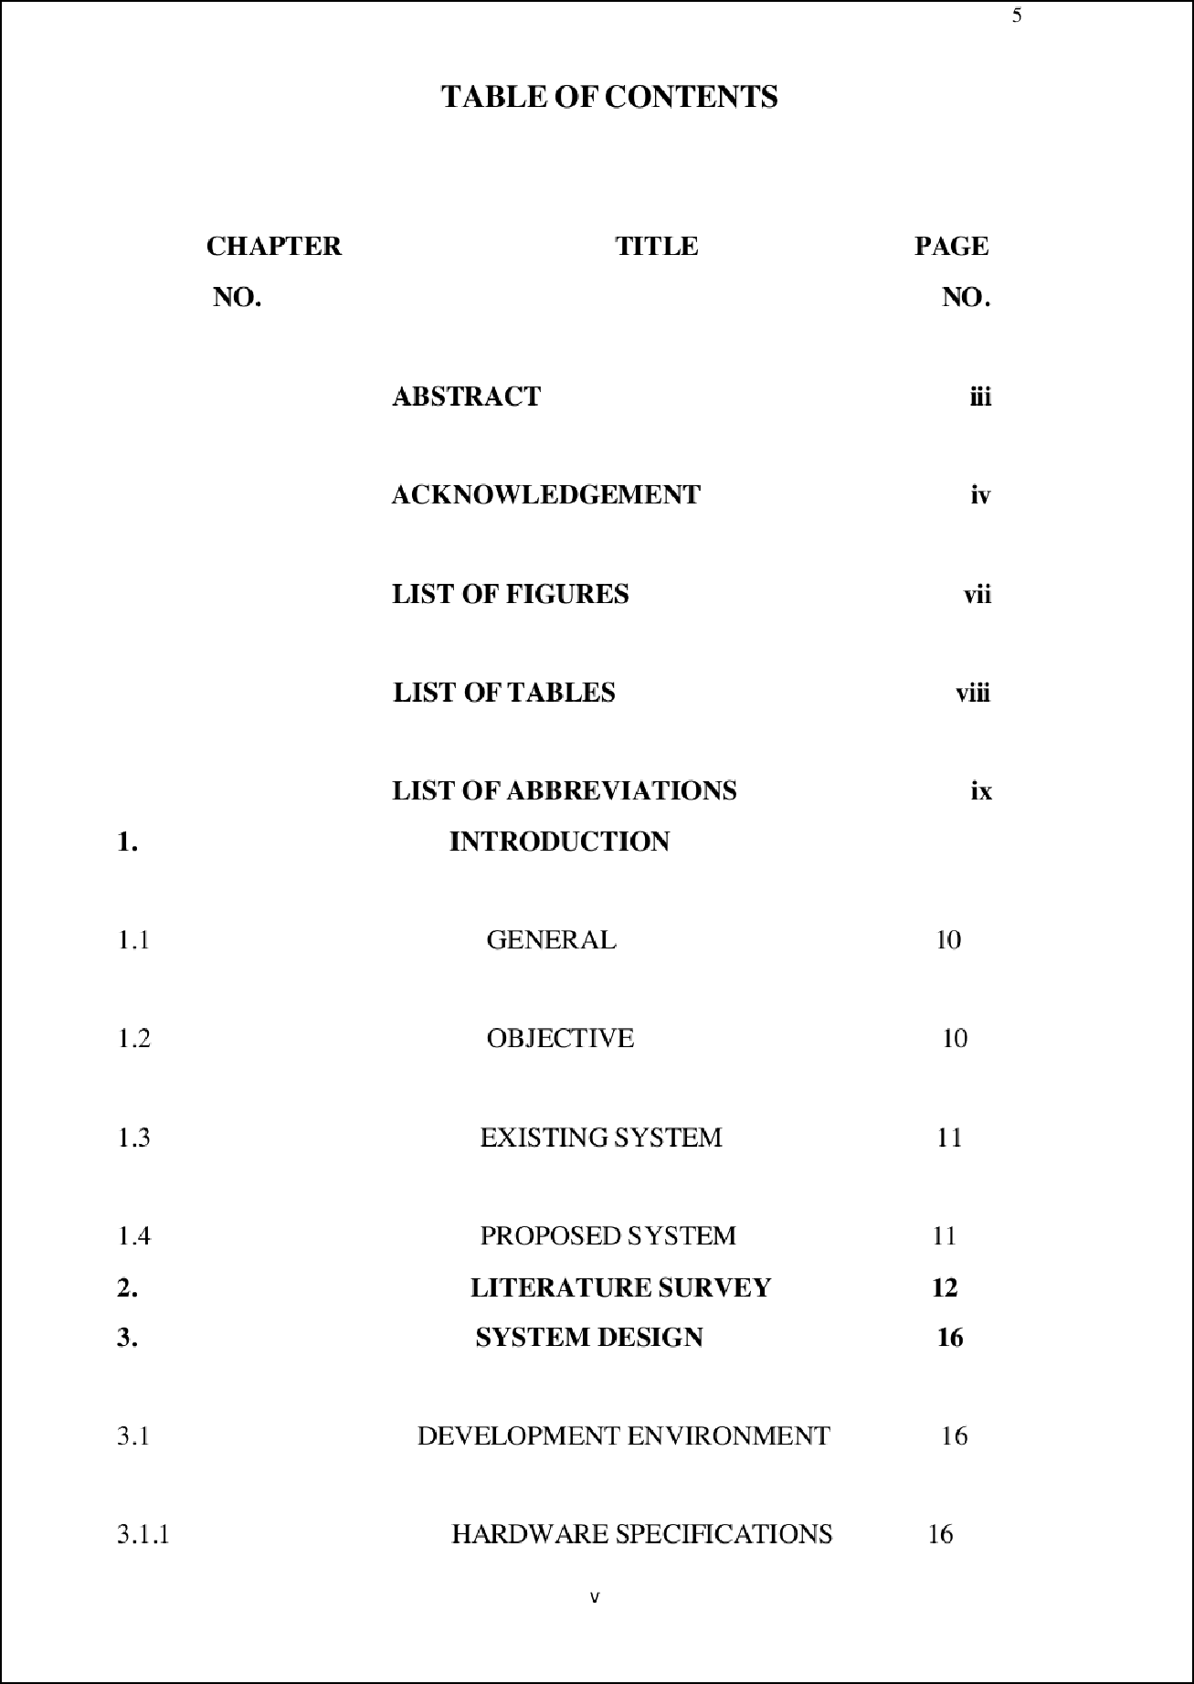

13

1

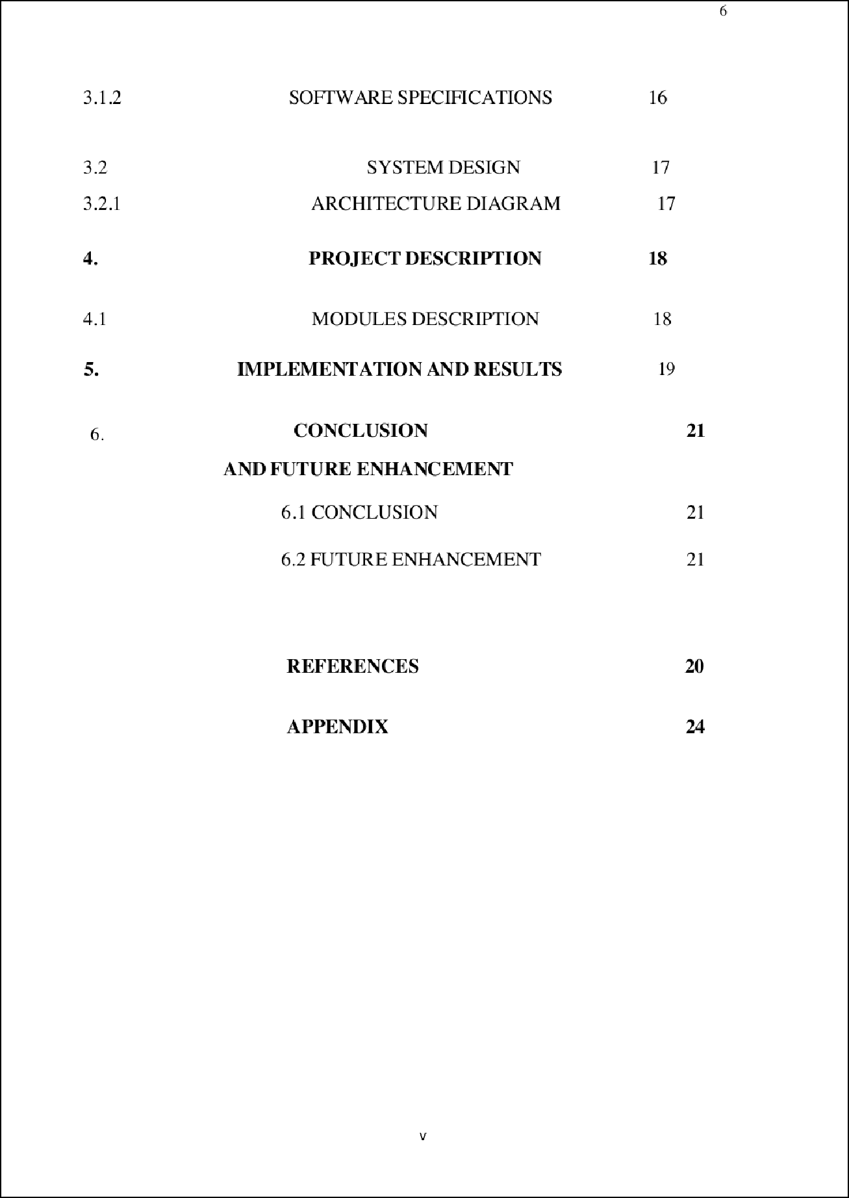

31

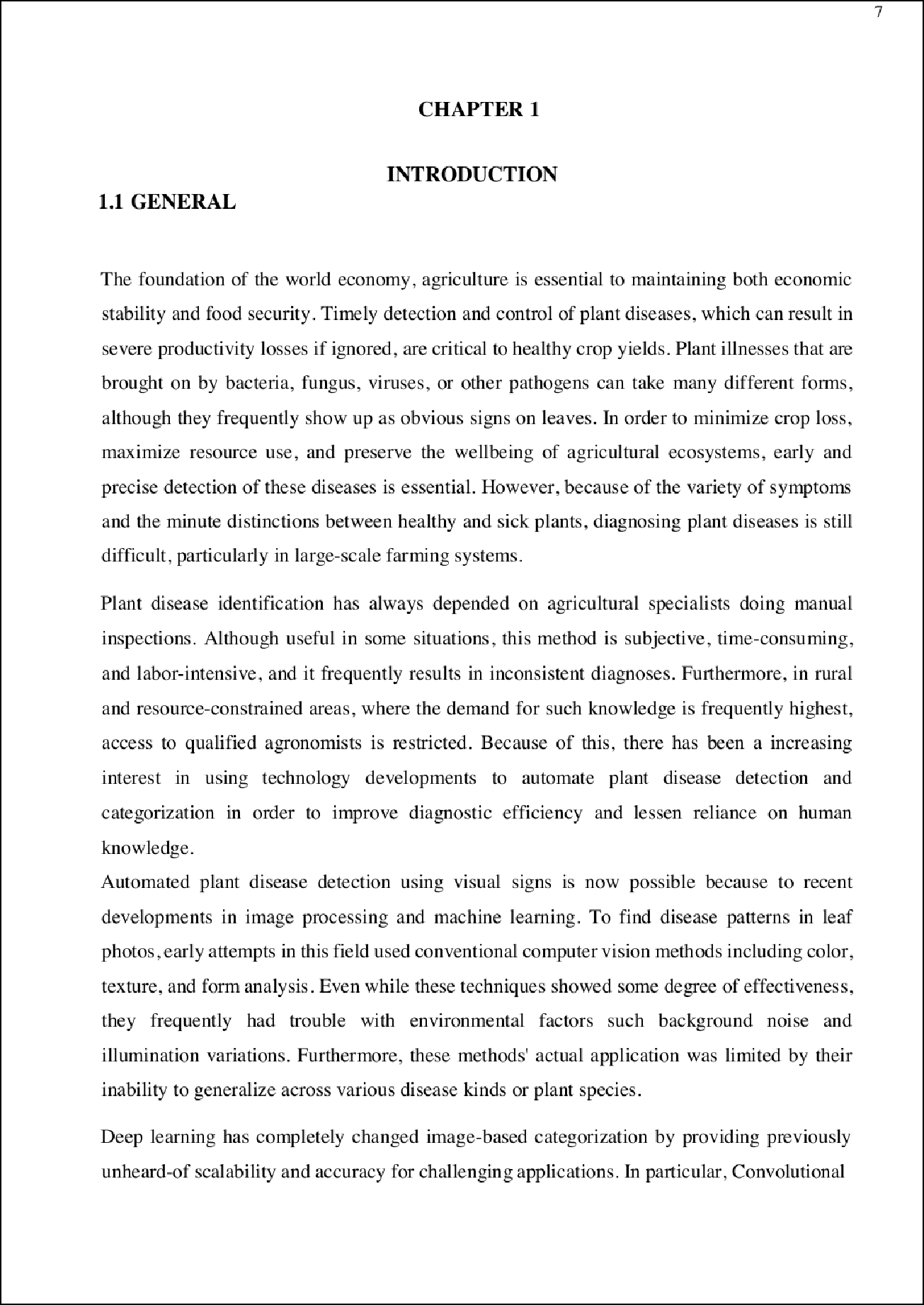

11

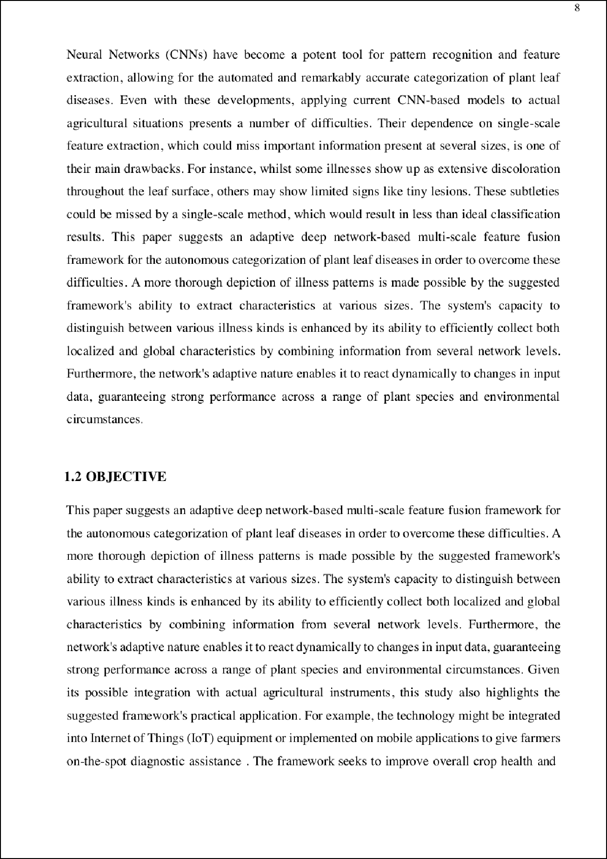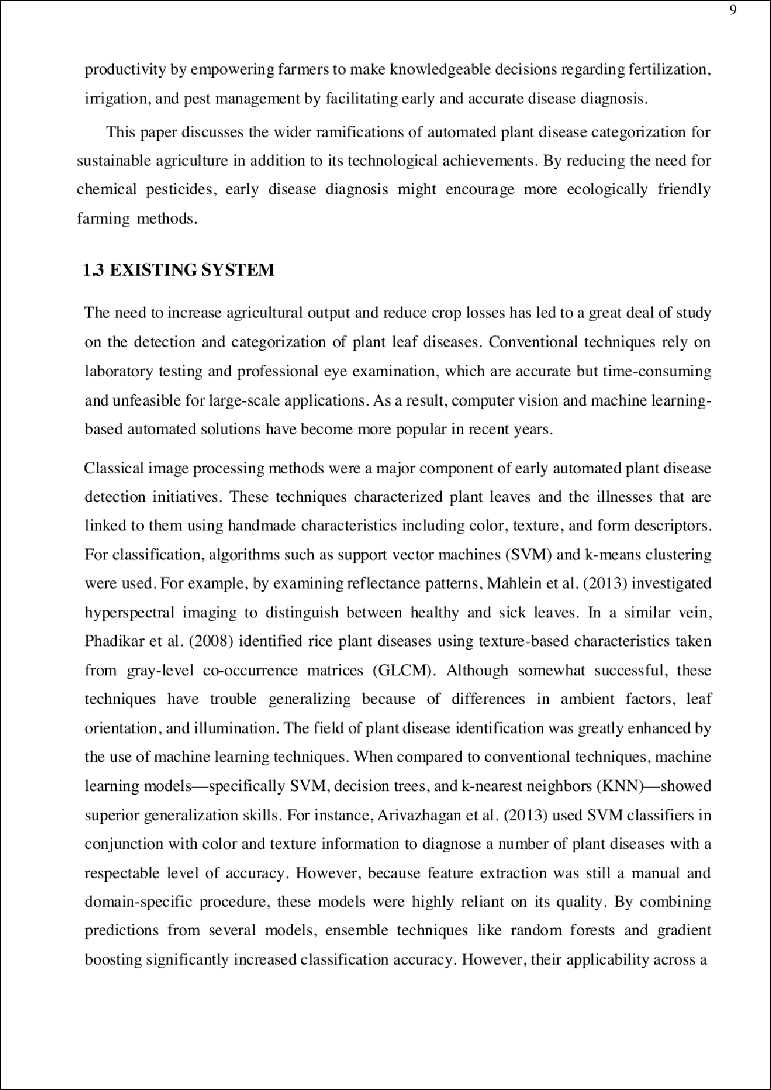

28

35

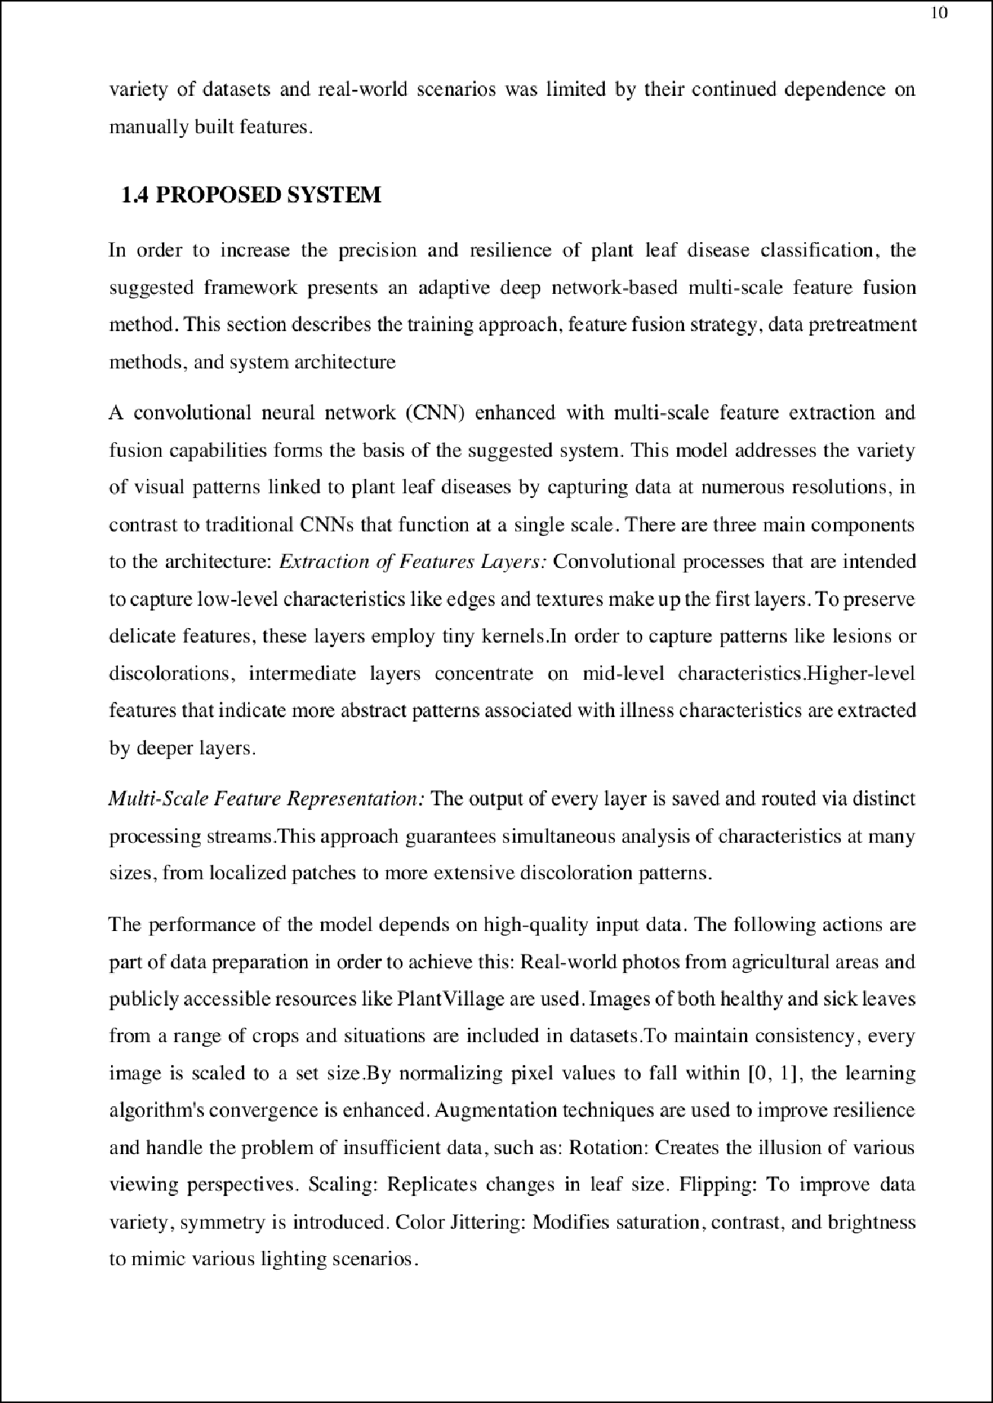

2

32

12

10

11

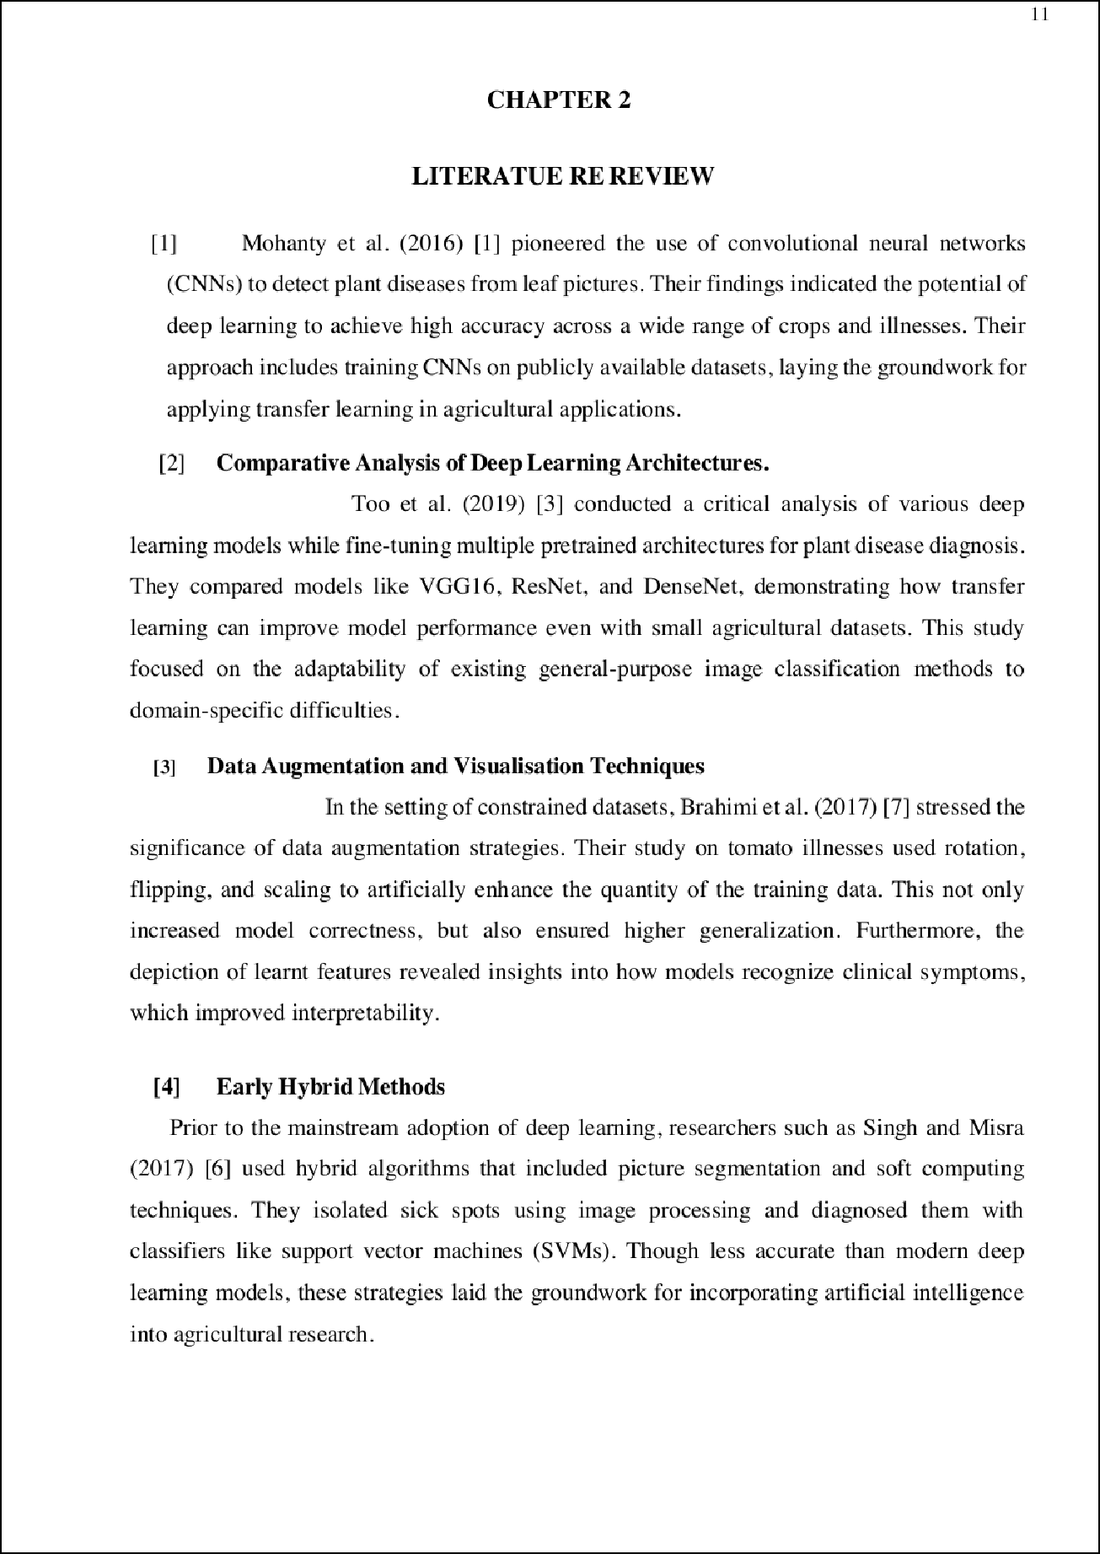

34

43

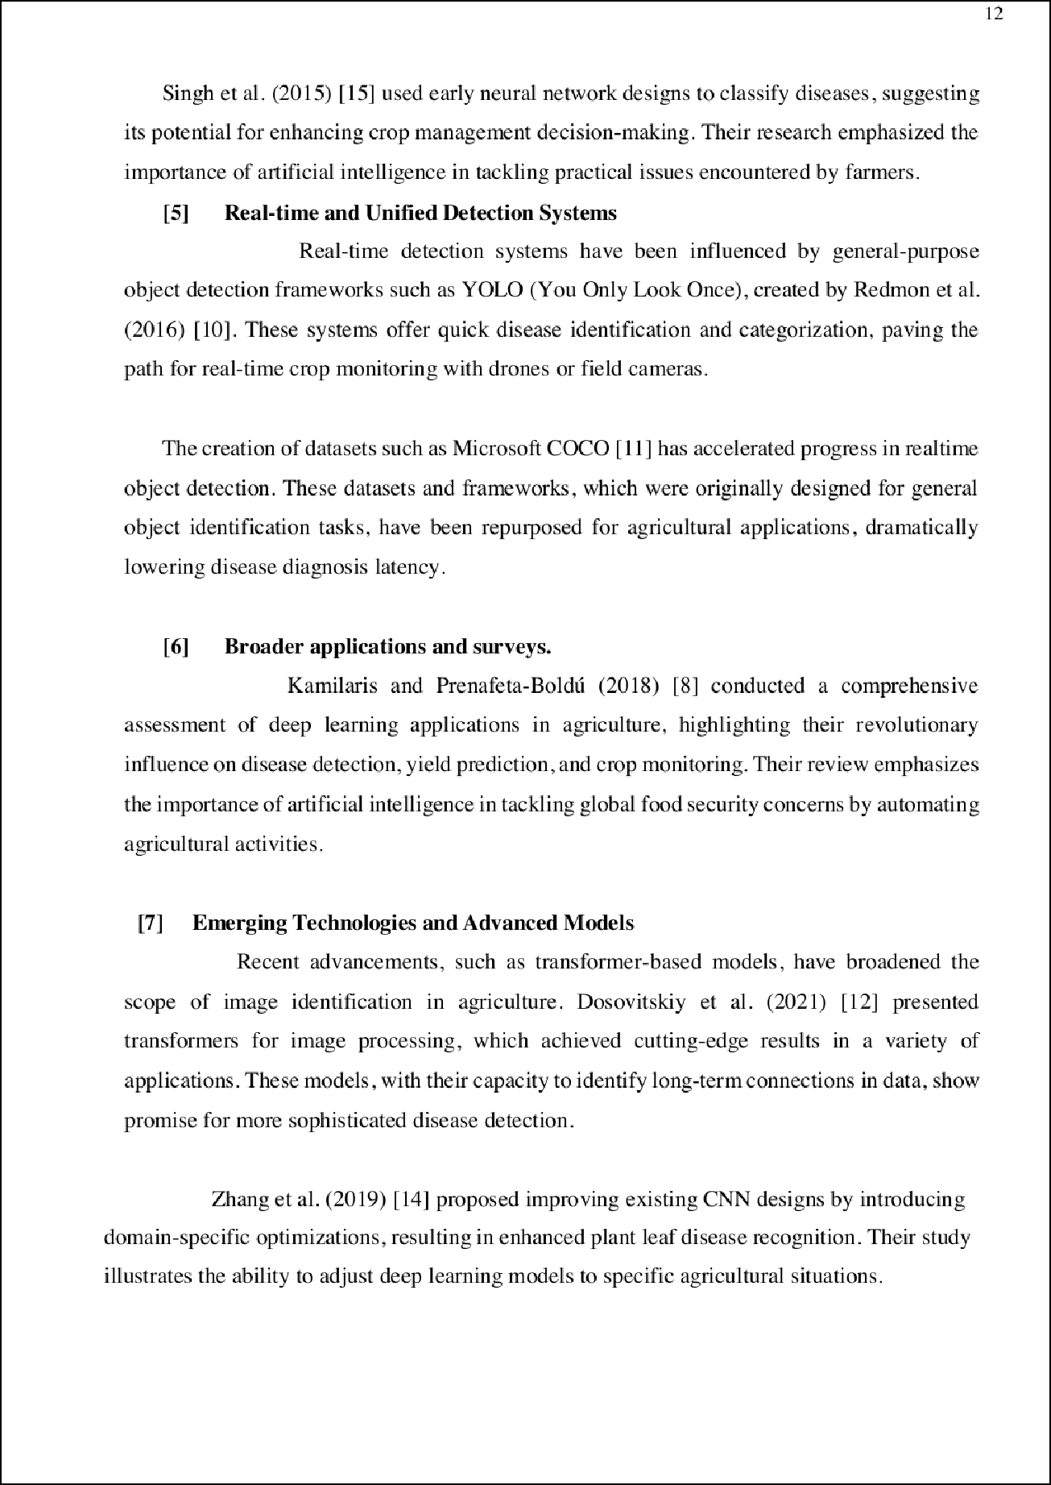

29

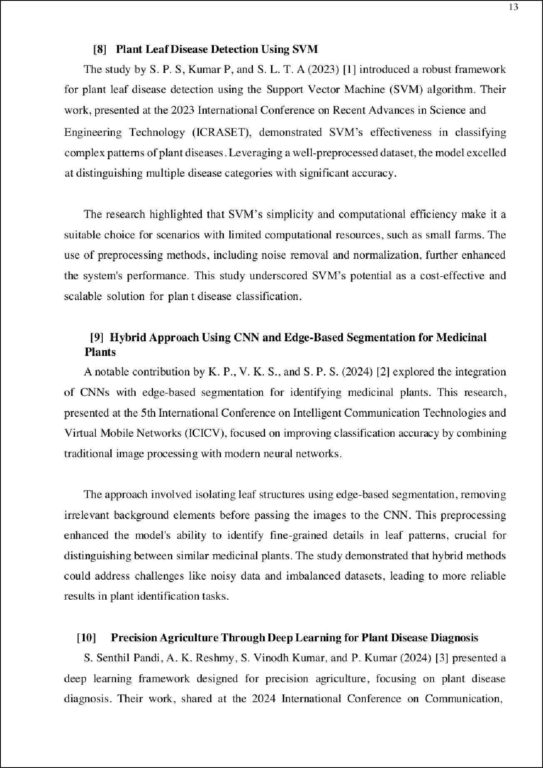

2

22

20

33

2

2

27

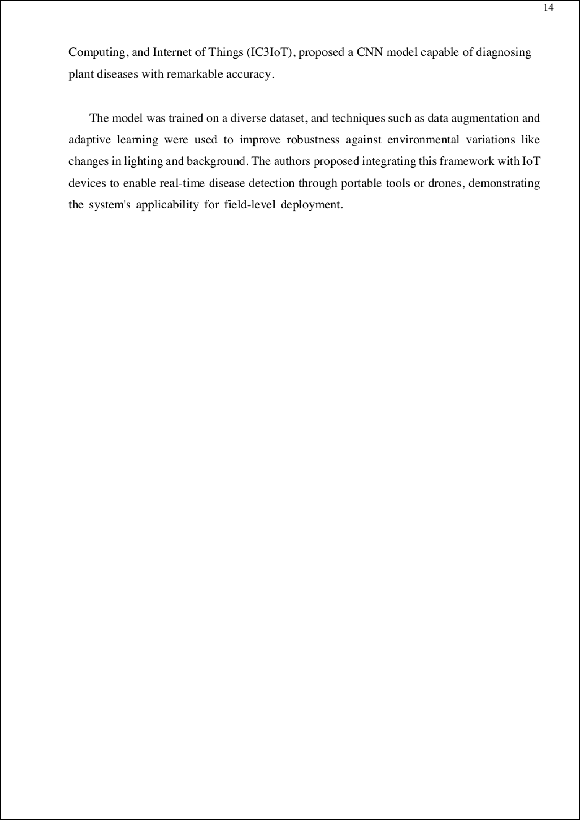

11 7

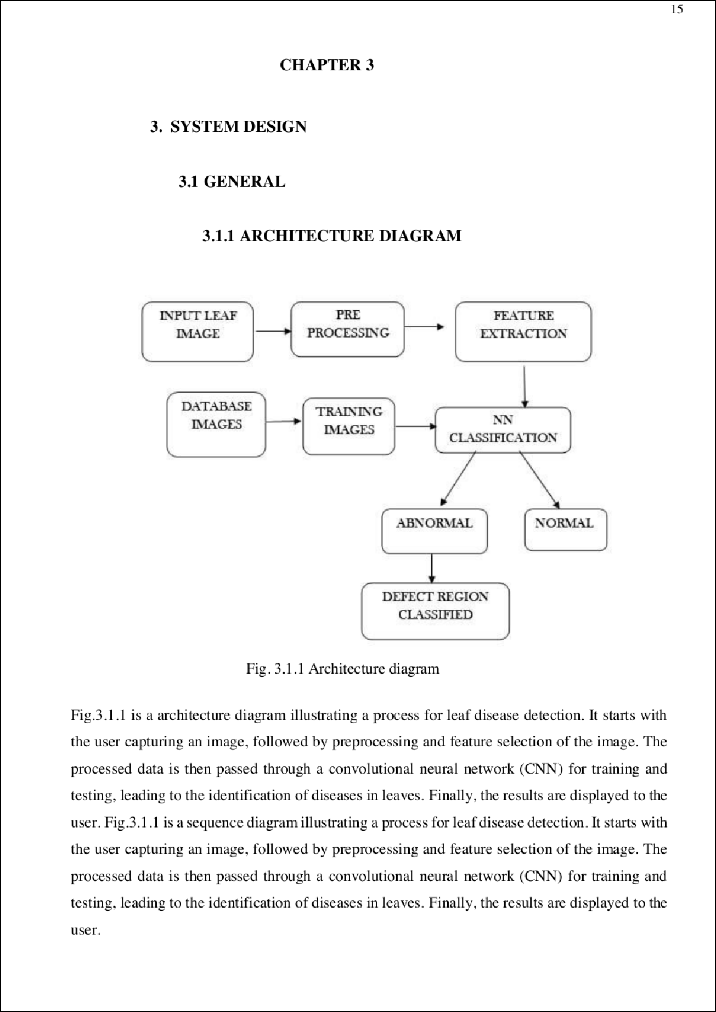

37

1

16

2

16

2

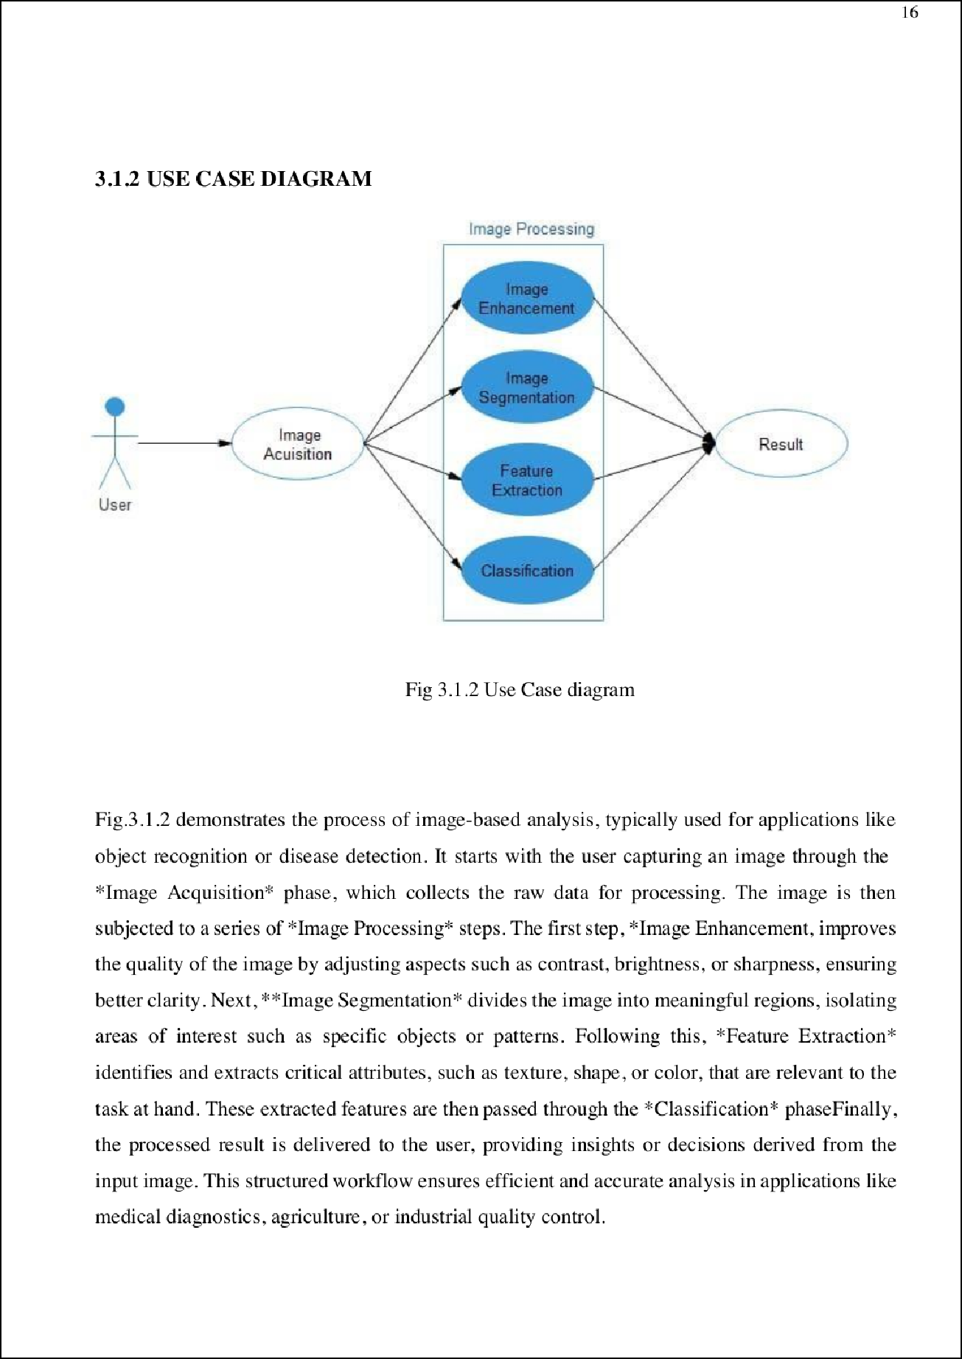

24

10

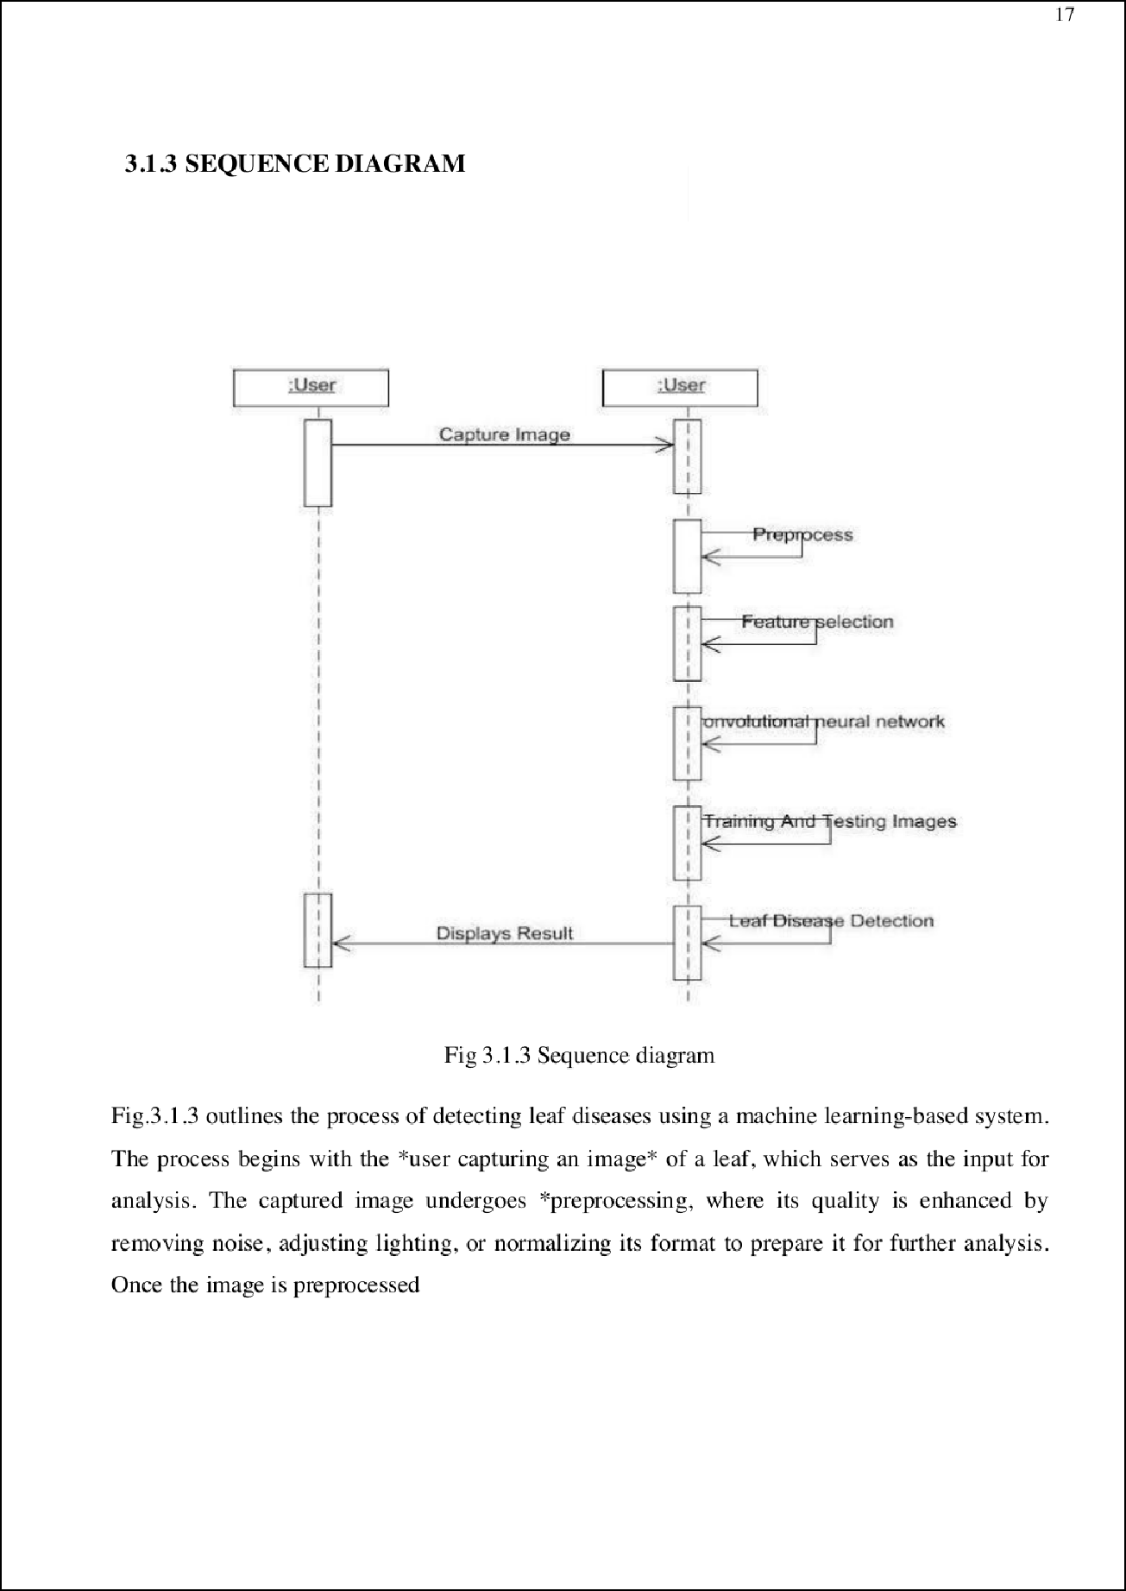

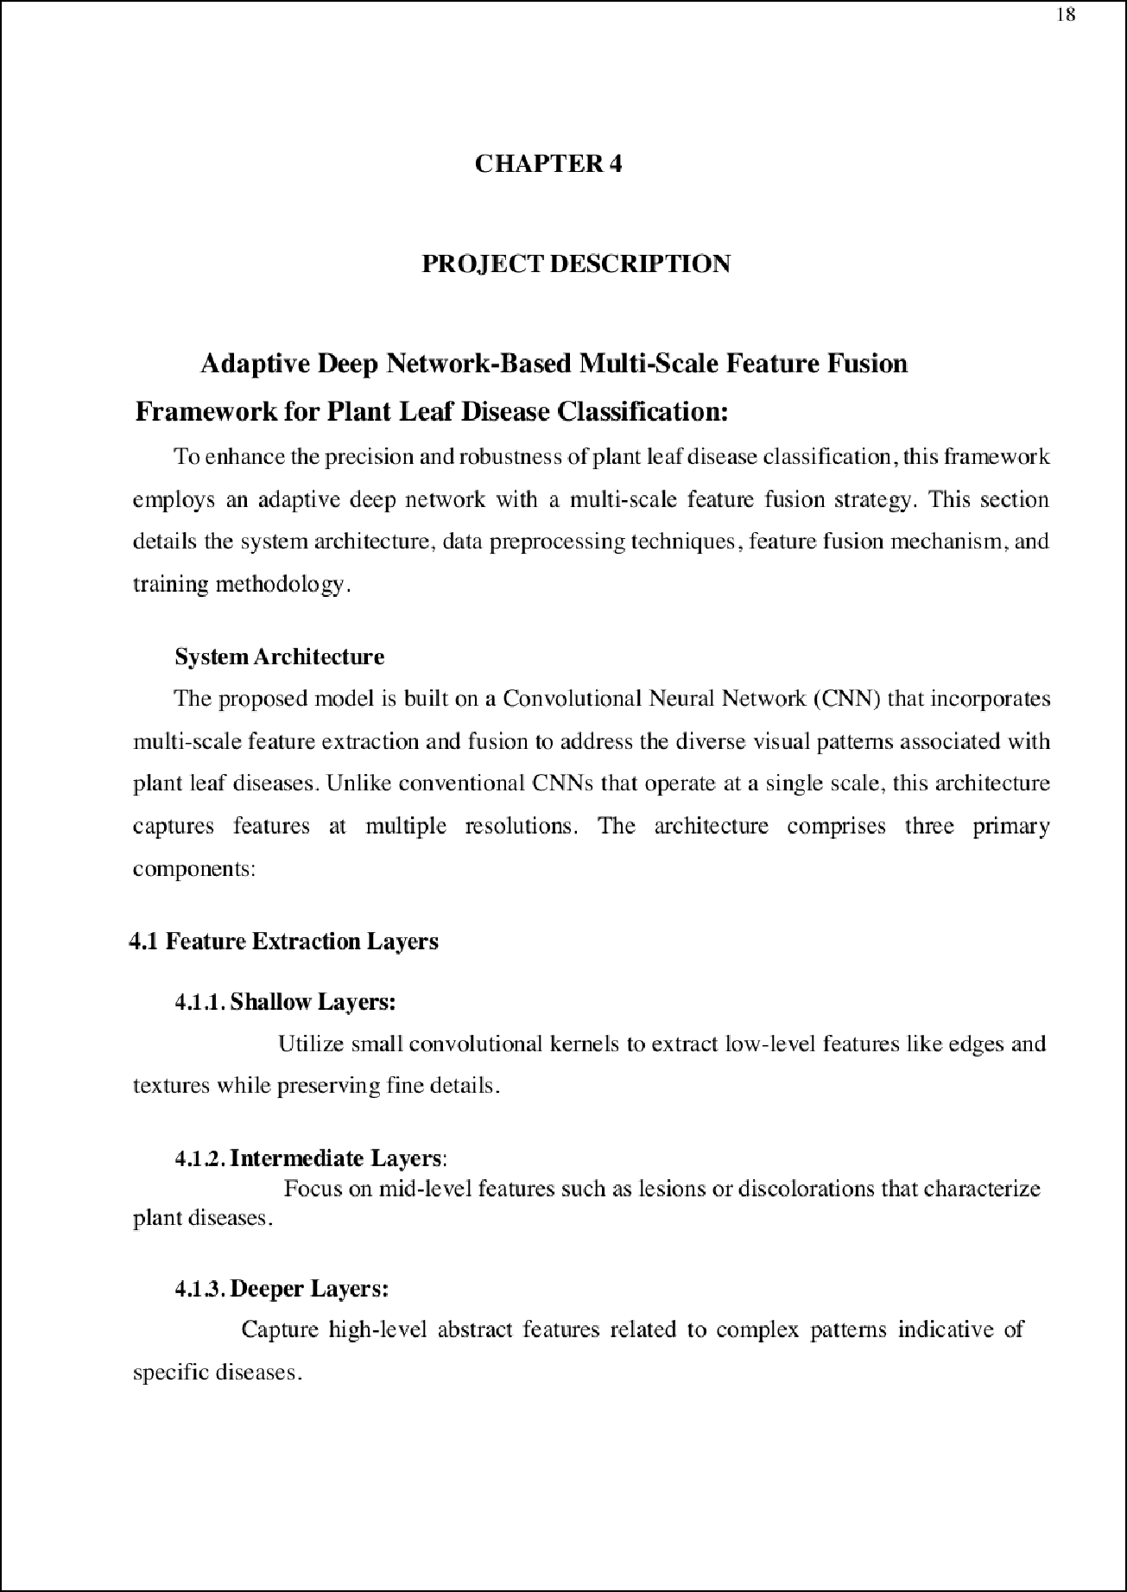

12

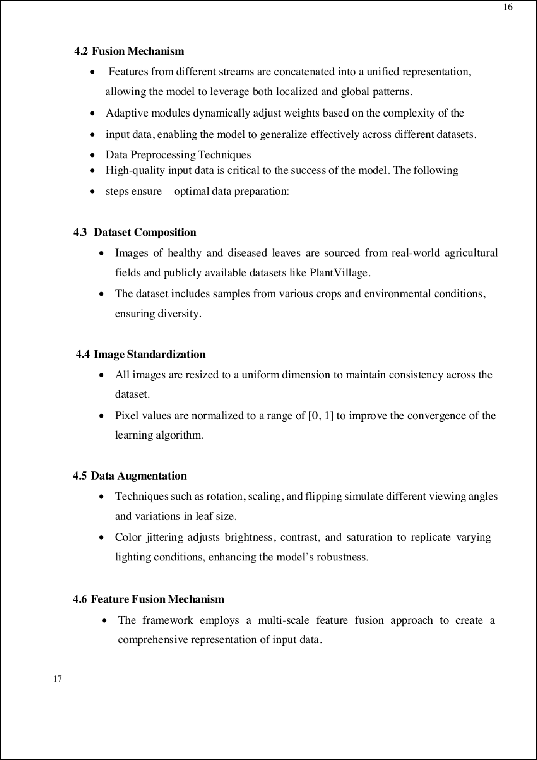

18

2

14

7

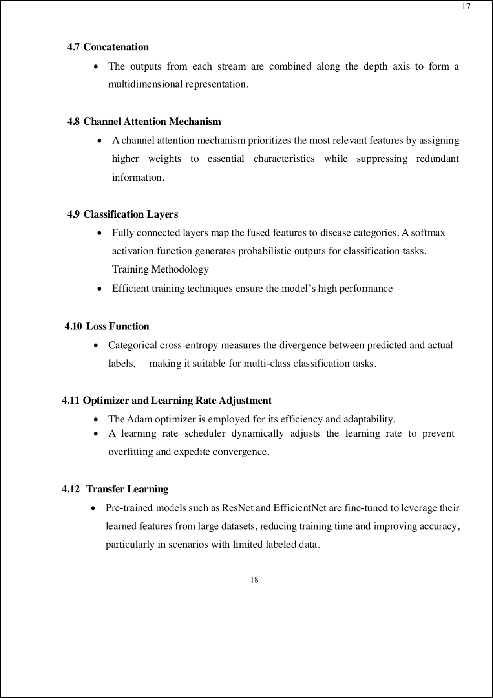

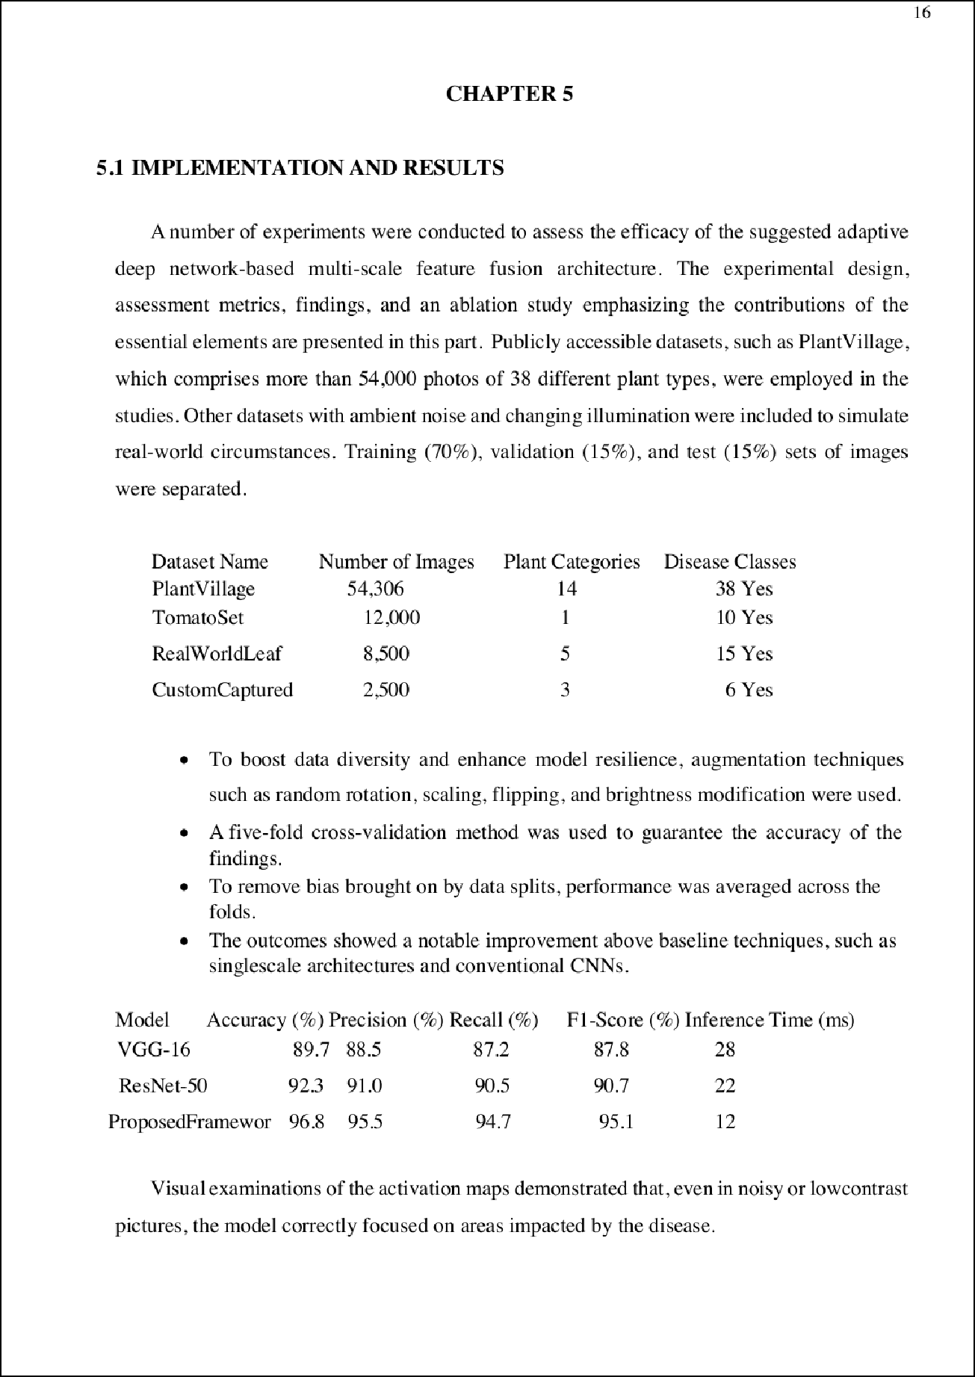

17

10

42

30

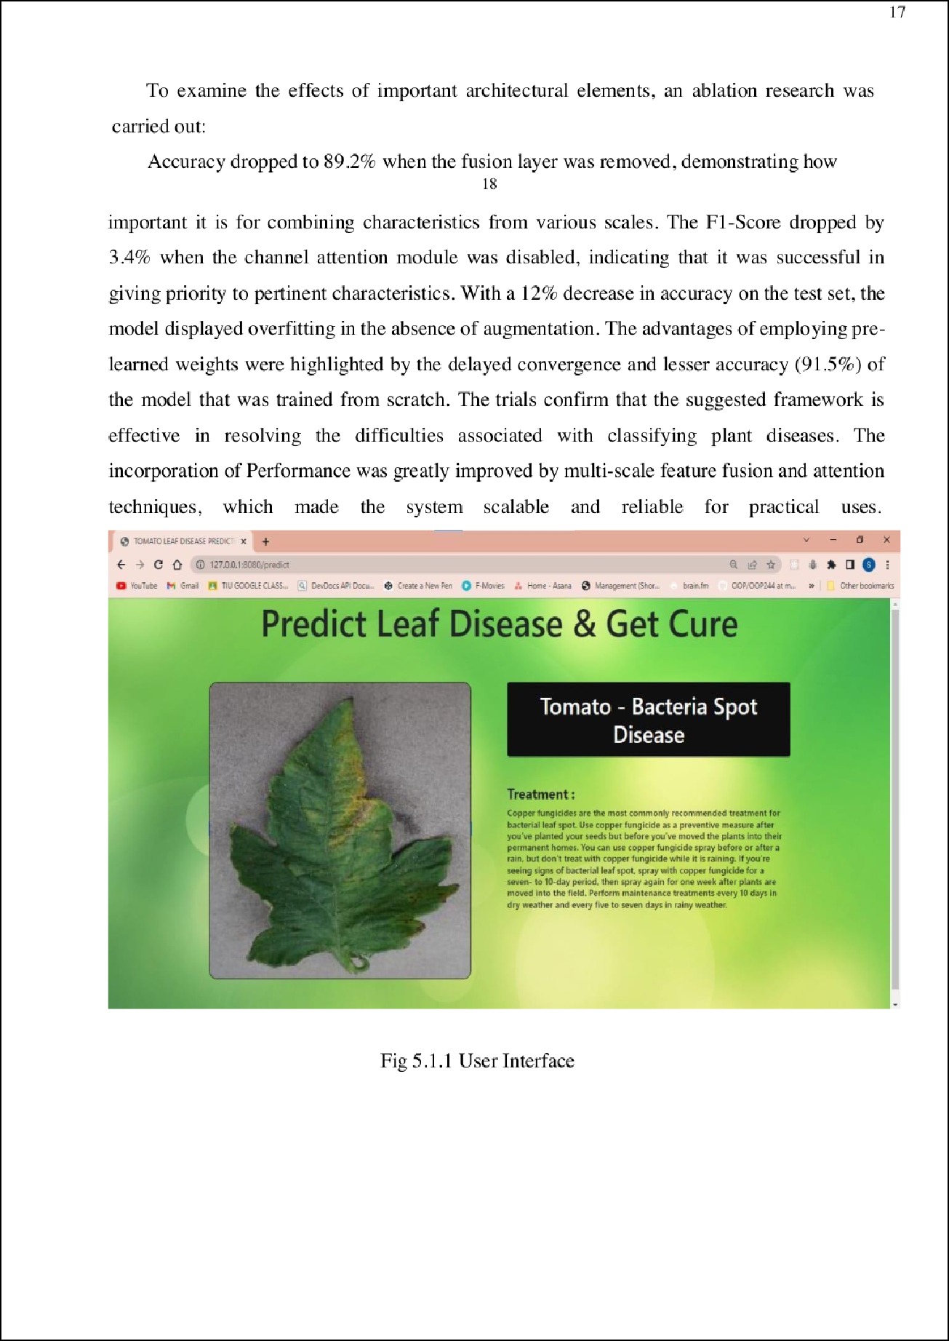

17

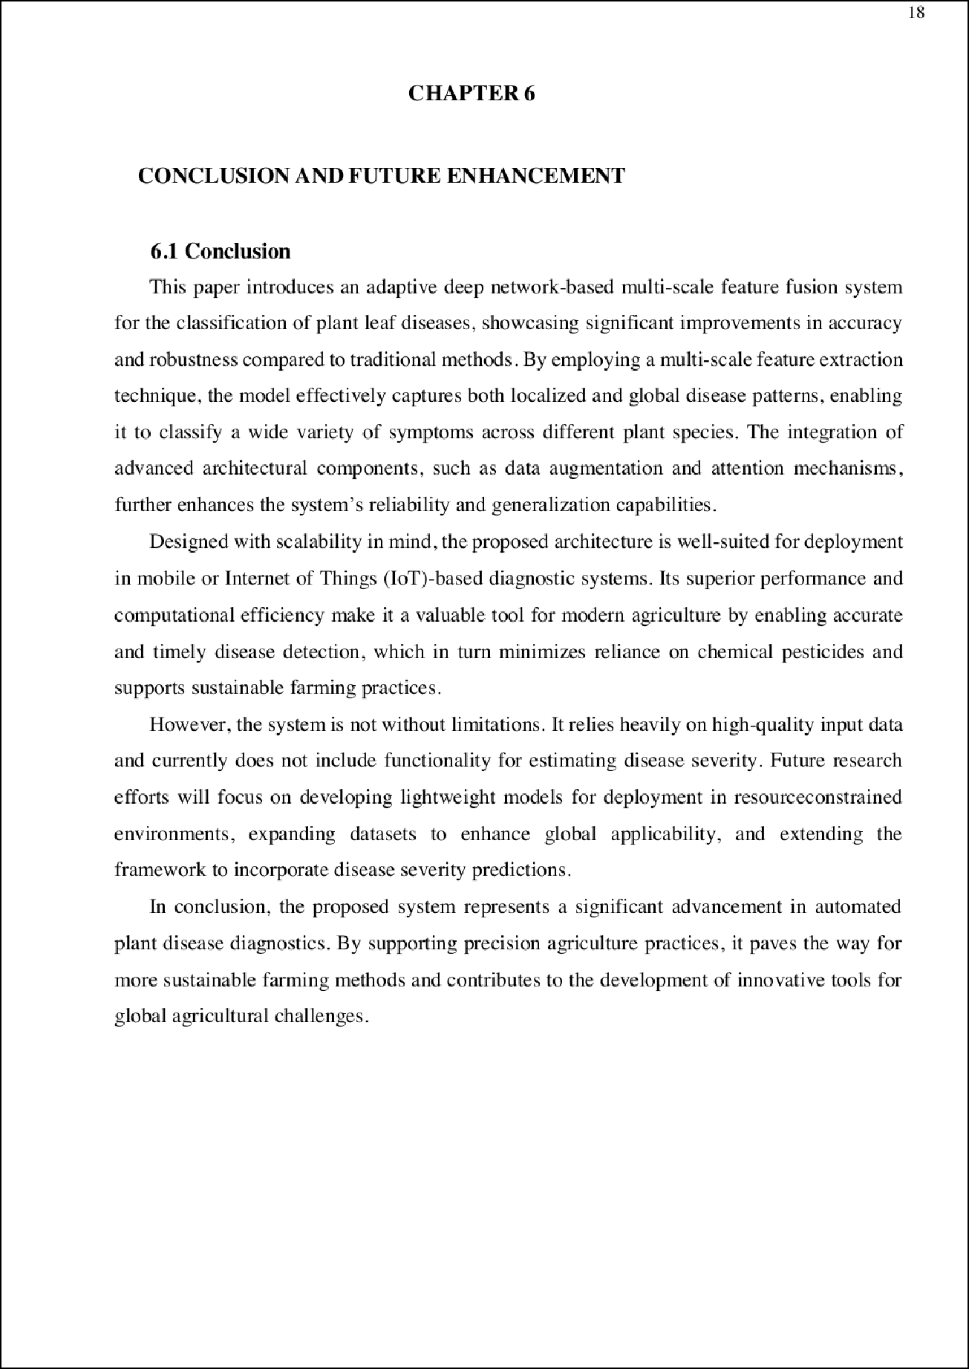

26

38

2

2

2

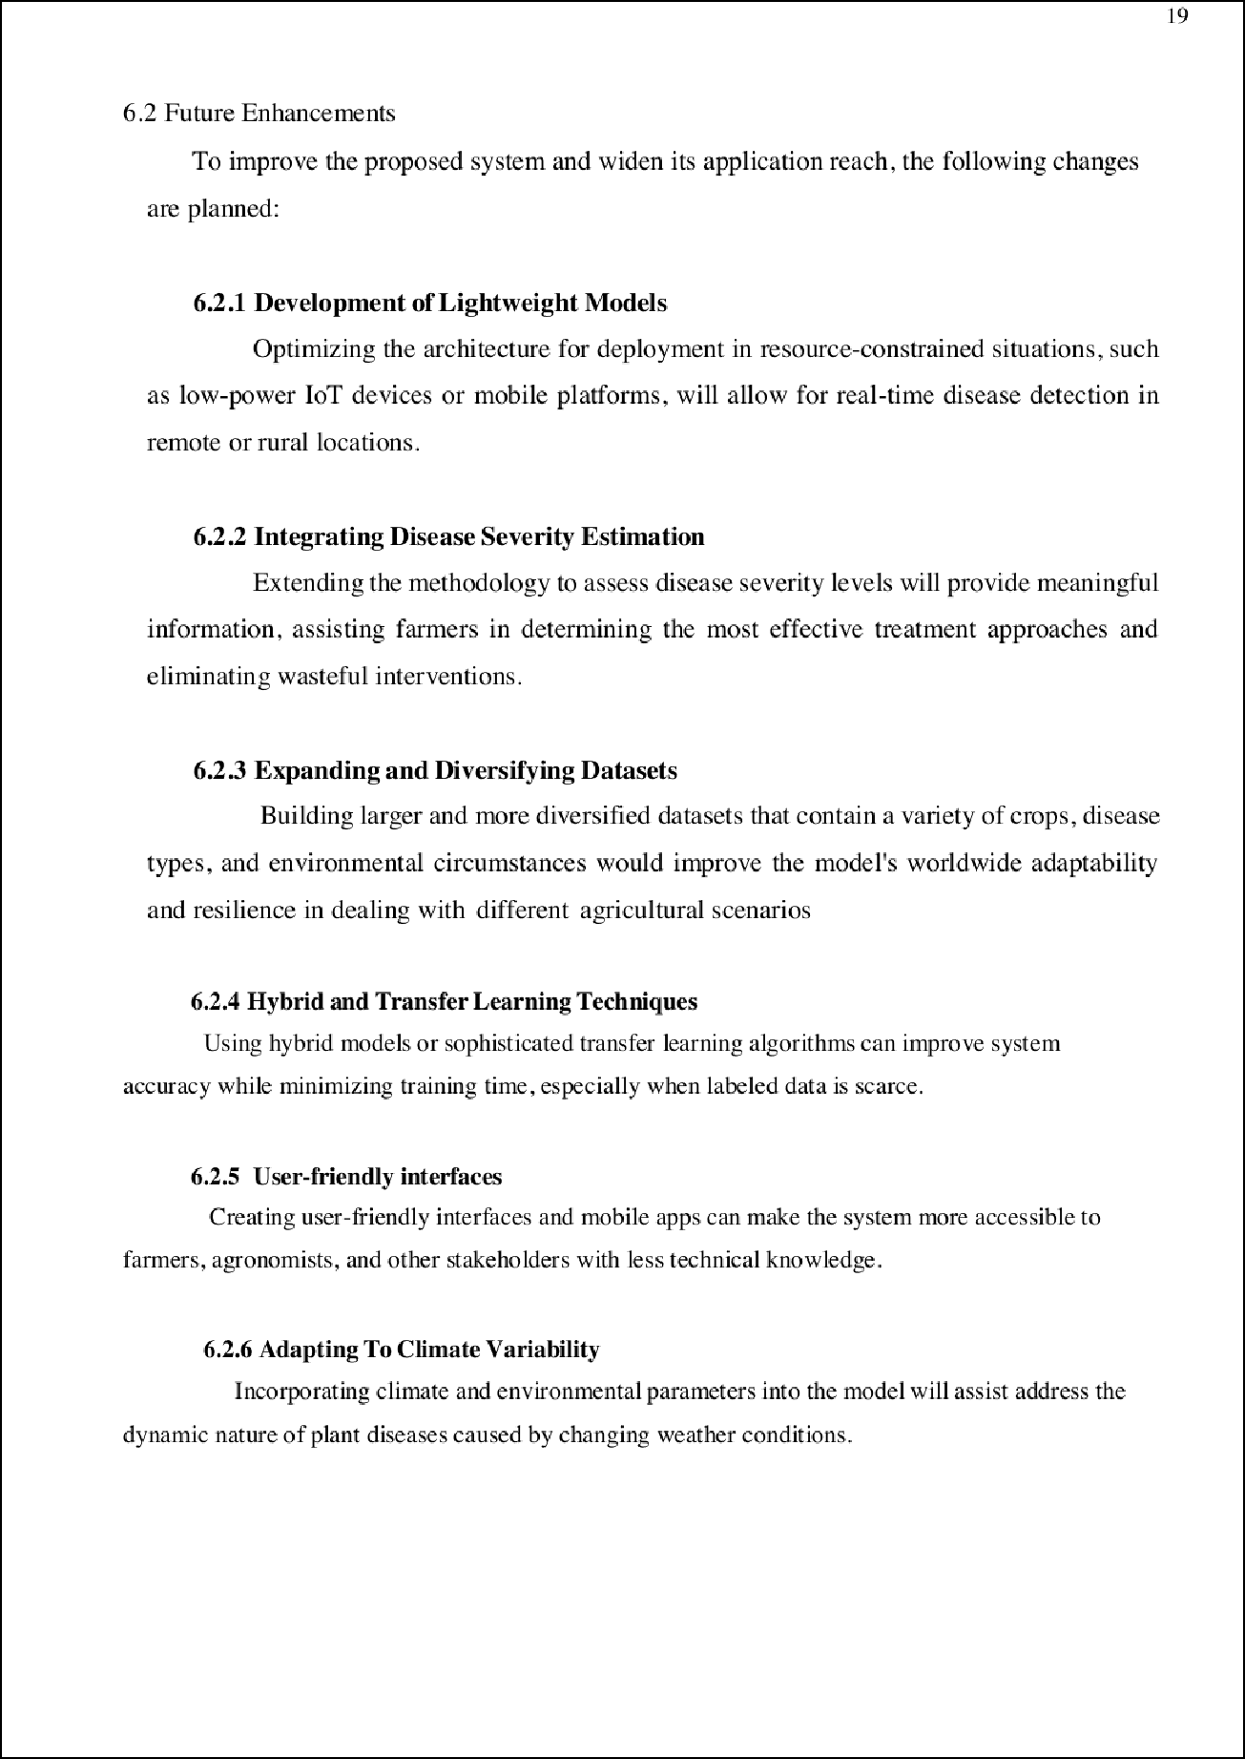

40

19

9

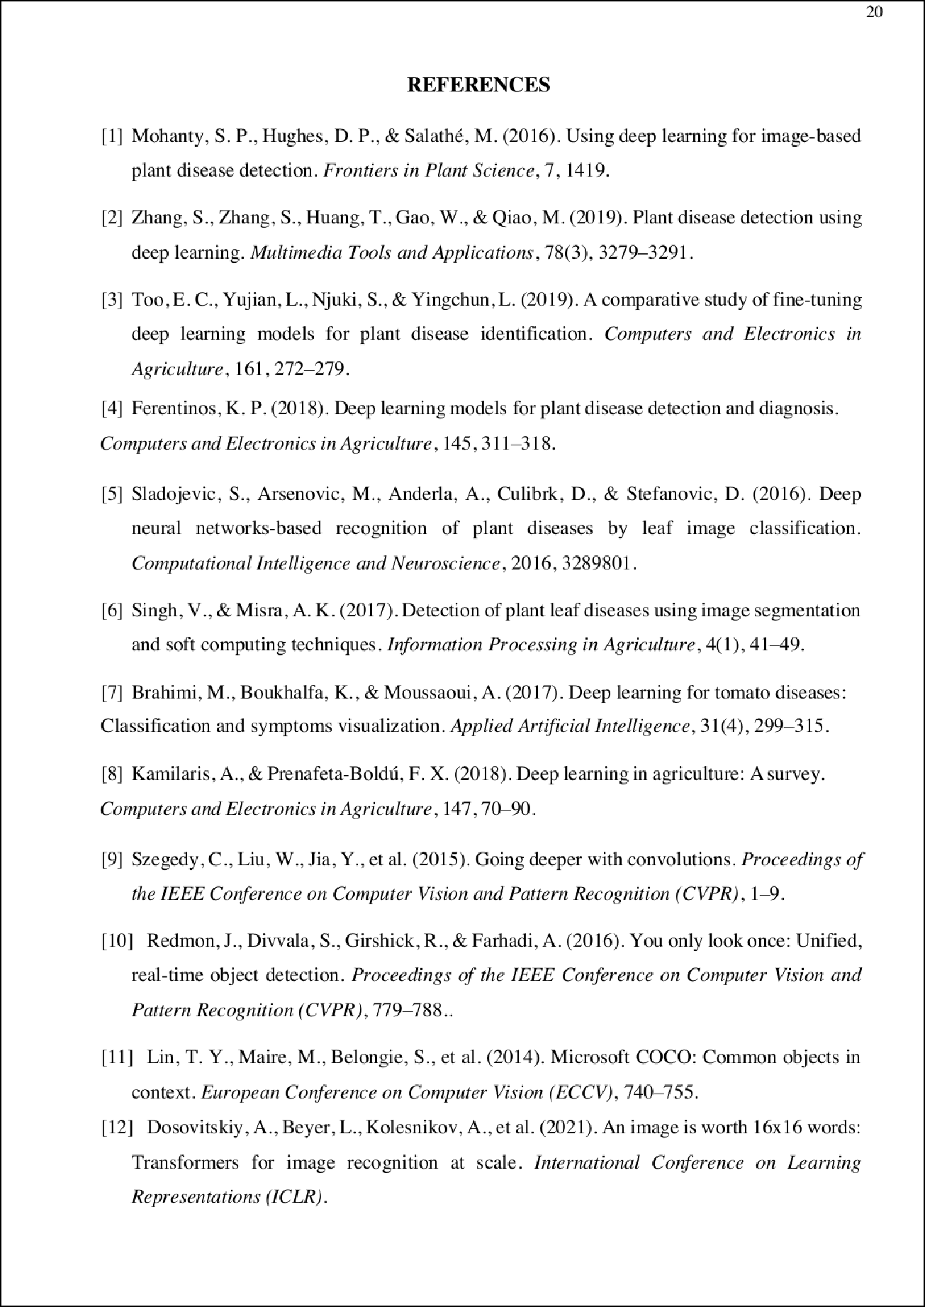

21 7

5

7

4

5

15

3 6

3

3

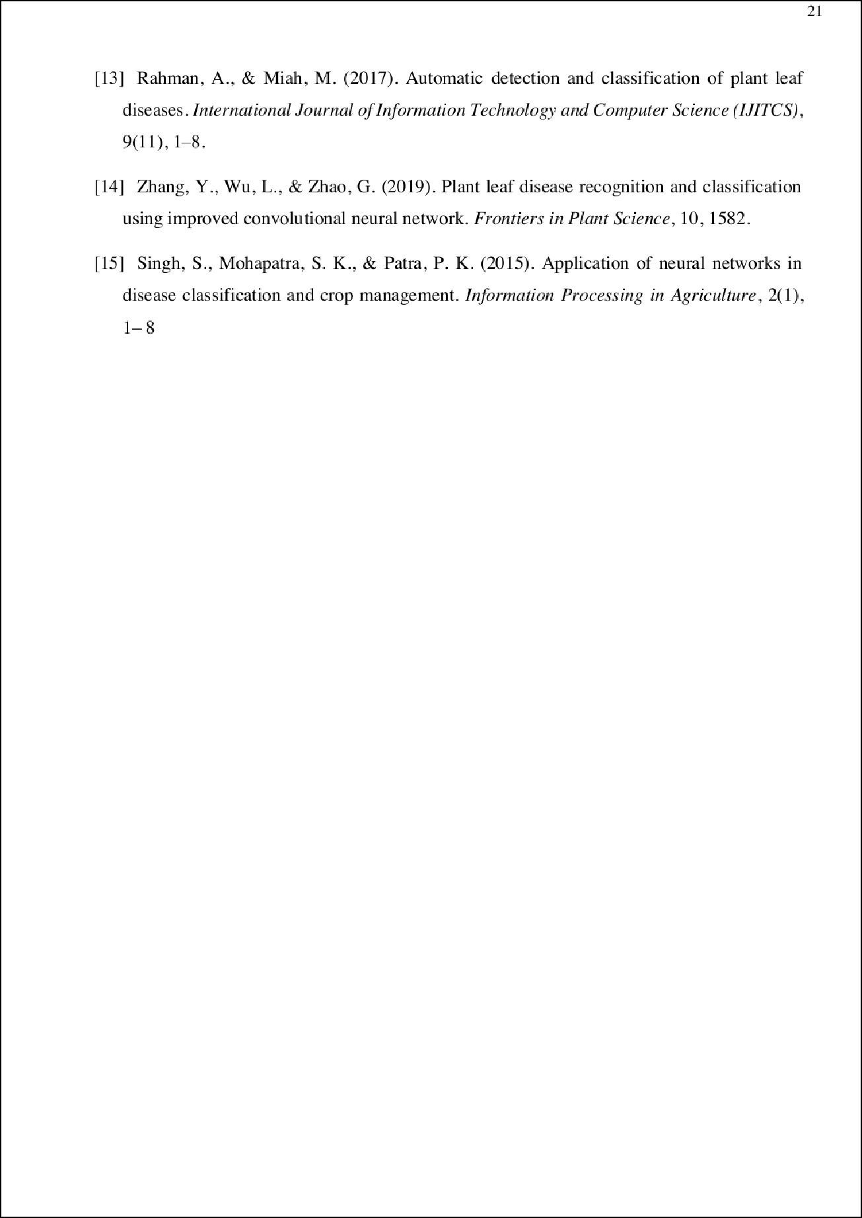

36

25

41





Lin re

ORIGINALITY REPORT

21

%

SIMILARITY INDEX

16%

INTERNET SOURCES

12%

PUBLICATIONS

14%

STUDENT PAPERS

PRIMARY SOURCES

1 Submitted to University of Illinois at Urbana- Champaign

Student Paper

6%

1%

2 V. Sharmila, S. Kannadhasan, A. Rajiv Kannan,

P. Sivakumar, V. Vennila. "Challenges in

Information, Communication and Computing Technology", CRC Press, 2024

Publication

1

[www.springerprofessional.de](http://www.springerprofessional.de/)

Internet Source %

3

1

cibgp.com

Internet Source %

4

1

krishi.icar.gov.in

Internet Source %

5

1

Submitted to Ace Acumen Academy

Student Paper %

6

1

link.springer.com

Internet Source %

7

1

Submitted to University of Canberra

Student Paper %

8

9

10

11

12

13

14

15

16

17

[www.iieta.org](http://www.iieta.org/)

Internet Source

"Proceedings of the International Conference on ISMAC in Computational Vision and Bio- Engineering 2018 (ISMAC-CVB)", Springer Science and Business Media LLC, 2019

Publication

ijarcsms.com

Internet Source

mdpi-res.com

Internet Source

[www.coursehero.com](http://www.coursehero.com/)

Internet Source

Submitted to Yeditepe University

Student Paper

Submitted to Berlin School of Business and Innovation

Student Paper

[www.frontiersin.org](http://www.frontiersin.org/)

Internet Source

Gonzalez, Emmanuel M.. "Interface Between Plant Science and Data Science: Extracting Insights From Phenomics Data", The University of Arizona, 2024

Publication

<1%

<1%

<1%

<1%

<1%

<1%

<1%

<1%

<1%

18

19

20

21

22

23

24

25

26

Zhanlin Ji, Ziheng Zhao, Xinyi Zeng, Jingkun Wang, Li Zhao, Xueji Zhang, Ivan Ganchev. "ResDSda_U-Net: A novel U-Net based residual network for segmentation of pulmonary nodules in lung CT images", IEEE Access, 2023

Publication

Submitted to La Trobe University

Student Paper

francisxavier.ac.in

Internet Source

kuey.net

Internet Source

[www.mdpi.com](http://www.mdpi.com/)

Internet Source

Submitted to SAMRAT ASHOK TECHNOLOGICAL INSTITUTE VIDISHA M.P

Student Paper

Submitted to Visvesvaraya Technological University

Student Paper

jestec.taylors.edu.my

Internet Source

[www.123seminarsonly.com](http://www.123seminarsonly.com/)

Internet Source

<1%

<1%

<1%

<1%

<1%

<1%

<1%

<1%

<1%

27

28

29

30

31

32

33

34

[www.nature.com](http://www.nature.com/)

Internet Source

ai4telcos.blogspot.com

Internet Source

[www.idr.iitkgp.ac.in](http://www.idr.iitkgp.ac.in/)

Internet Source

[www.researchsquare.com](http://www.researchsquare.com/)

Internet Source

dokumen.pub

Internet Source

iieta.org

Internet Source

A Divya, D Sungeetha, Sundar Ramesh. "Eﬃcient protection of golden nutri cereal implementing enhanced disease identiﬁcation injecting hybrid split-attention mechanism through Novel SANDNES Mechanism", Multimedia Tools and Applications, 2024

Publication

Albert C. Cruz, Andrea Luvisi, Luigi De Bellis, Yiannis Ampatzidis. "X-FIDO: An Eﬀective Application for Detecting Olive Quick Decline Syndrome with Deep Learning and Data Fusion", Frontiers in Plant Science, 2017

Publication

<1%

<1%

<1%

<1%

<1%

<1%

<1%

<1%

35

36

37

38

39

40

41

42

43

Arvind Dagur, Karan Singh, Pawan Singh Mehra, Dhirendra Kumar Shukla. "Artiﬁcial Intelligence, Blockchain, Computing and Security", CRC Press, 2023

Publication

Mehmet Metin Ozguven, Kemal Adem. "Automatic detection and classiﬁcation of leaf spot disease in sugar beet using deep learning algorithms", Physica A: Statistical Mechanics and its Applications, 2019

Publication

Submitted to University of Wollongong

Student Paper

ebin.pub

Internet Source

ejmcm.com

Internet Source

iarjset.com

Internet Source

ijritcc.org

Internet Source

publikationen.bibliothek.kit.edu

Internet Source

Morales, Mario Andres. "High-Throughput Phenotyping of Seed Quality Traits Using Imaging, Computer Vision, and Deep

<1%

<1%

<1%

<1%

<1%

<1%

<1%

<1%

<1%

Learning in Pulse Crop", North Dakota State University, 2024

Publication

Exclude quotes Oﬀ Exclude bibliography Oﬀ

Exclude matches Oﬀ